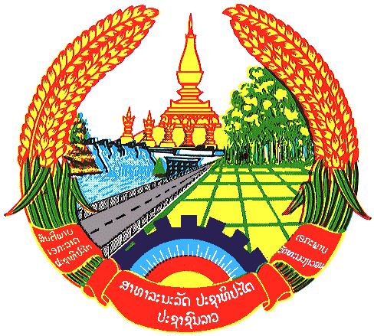

Statement by the delegation of the Lao PDR
At the 27th Session of UPR Working Group
Geneva, 1-12 May 2016
----------------

Review of the Republic of Indonesia, 3 May 2017, at 9:00-12:30 hours

Mr. President,

As the ASEAN Fellow Country the Lao delegation warmly welcomes the distinguished delegation of the Republic of Indonesia and would like to thank for its comprehensive presentation of the National Human Rights Report.

My delegation welcomes the unwavering commitment of the Government of Indonesia to further accelerate efforts to realize the full enjoyment of human rights in the country by accelerating national development through the development of its periphery areas. We also please to note Indonesia’s active participation in the work of the Human Rights Council, and engaging with other human rights mechanisms and treaty bodies as well as in the work of ASEAN Intergovernmental Commission on Human Right “AICHR”.

Lao PDR commends the progress development made by the government of Indonesia on social-economic along with promotion of human rights. Particularly, we commend progress on promotion rights of the vulnerable group including women, children and person with disabilities, enhancing freedom of opinion and expression, freedom of religion and improving health care services.

My delegation wishes to make following recommendations:

- To step up its efforts in closing the current economic disparities.
- To redouble its campaign to enhance women’s role in politics and in the public sphere.

We wish Indonesia every success in its Third Cycle of UPR.

I thank you

